H.T No
Regulations:
A18

Sreenidhi Institute of Science and Technology
(An Autonomous Institution)
Code No: 7AC02 Date: 24-Mar-2023 (AN)

B.Tech I-Year I- Semester External Examination, March/April-2023 (Supplementary)
NETWORK ANALYSIS (ECE)

Time: 3 Hours Max.Marks:70

Note: a) No additional answer sheets will be provided.
b) All sub-parts of a question must be answered at one place only, otherwise it will not be valued.
c) Missing data can be assumed suitably.
Bloom's Cognitive Levels of Learning (BCLL)

Remember | L1 | Apply | L3 | Evaluate | L5
Understand | L2 | Analyze | L4 | Create | L6

Part - A Max.Marks:20

Answer all QUESTIONS.

 |  | BCLL | CO(s) | Marks
1 | What are dependent and independent sources? | L2 | CO1 | [2M]
2 | Define cut set matrix. | L2 | CO2 | [2M]
3 | What is leakage flux? | L1 | CO3 | [2M]
4 | Define apparent power and power factor. | L2 | CO4 | [2M]
5 | Define Half power frequencies and quality factor. | L2 | CO5 | [2M]
6 | State Compensation theorem. | L1 | CO6 | [2M]
7 | Explain the purpose of star delta transformation. | L1 | CO2 | [2M]
8 | Define RMS value or effective value of an alternating quantity. | L2 | CO3 | [2M]
9 | Write the characteristics of series and parallel resonance. | L1 | CO5 | [2M]
10 | Define self and mutual inductance. | L2 | CO6 | [2M]

Part – B Max.Marks:50
ANSWER ANY FIVE QUESTIONS. EACH QUESTION CARRIES 10 MARKS.

 |  |  | BCLL | CO(s) | Marks
11. | a) | Find the power delivered by the voltage and the current source in the circuit shown in fig  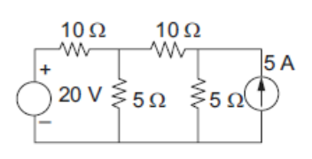 | L3 | CO1 | [5M]
 | b) | Determine the current delivered by the source in the circuit shown in fig  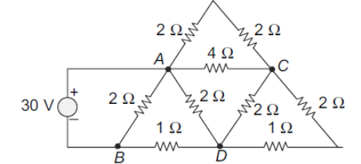 | L3 | CO1 | [5M]
12. | a) | Find the power delivered by independent voltage source in the network by loop analysis. Prepare the network graph using the reference directions marked in the fig.  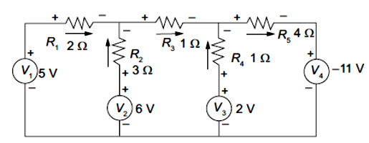 | L3 | CO2 | [5M]
 | b) | Find the mesh matrix B_{m} of the graph that has an f-circuit matrix B_{f} given by  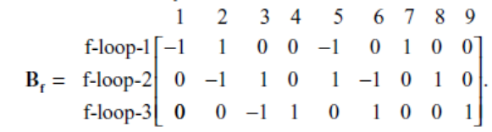 , also express all the branch currents in terms of the mesh currents. | L3 | CO2 | [5M]
13. | a) | In the coupled circuit find the voltage across the 5Ω resistor.  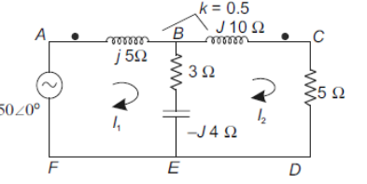 | L3 | CO3 | [5M]
 | b) | Calculate the mmf required to produce a flux of 5mWb across an air gap of 2.5mm of length having an effective area of 100cm² of cast steel ring of mean iron path of 0.5m and cross sectional area of 150 cm² as shown in fig. The relative permeability of cast steel is 800. Neglect leakage flux.  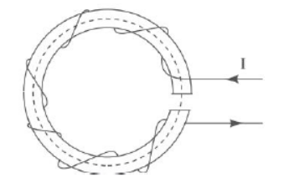 | L3 | CO3 | [5M]
14. | a) | A two element series circuit is connected across ac source e(t) = 200√2 sin(wt+20⁰) V. The current in the circuit is then found  to be i(t) = 10√2cos(wt-25⁰) A. Determine the parameters of the circuit. | L3 | CO4 | [5M]
 | b) | In the parallel circuit shown in fig, the power in the 5Ω resistor is 600W and the total circuit takes 3000 VA at a leading power factor of 0.707. Find the value of impedance Z.  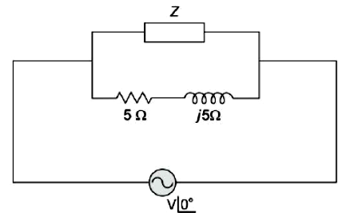 | L3 | CO4 | [5M]
15. | a) | For the circuit shown in fig. The applied voltage v(t) = 15 sin 1800t. Determine the resonant frequency. Calculate the quality factor and bandwidth. Compute the lower and upper limits of bandwidth.  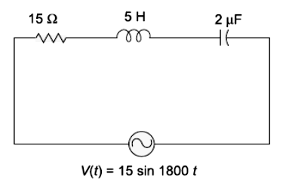 | L3 | CO5 | [5M]
 | b) | For a parallel circuit shown in fig. Plot the locus of currents.  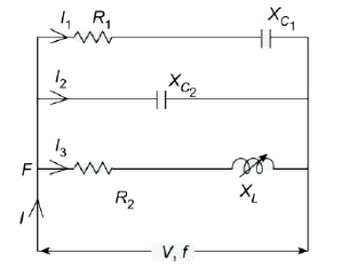 | L3 | CO5 | [5M]
16. | a) | Find the value of R in the circuit in fig, if i_{x} is to be zero. If i_{x} was seen to be 0.01 mA find the value of R by using compensation theorem.  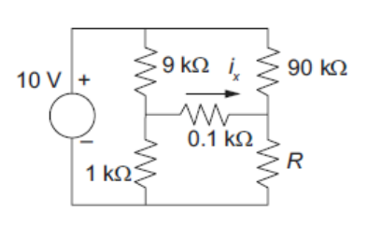 | L3 | CO6 | [5M]
 | b) | In the circuit shown in fig the resistance R_{g} is variable 2 and 55 ohms. What value of R_{g} results in maximum power transfer across terminals AB.  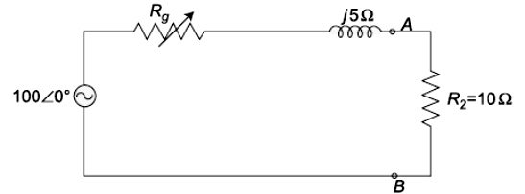 | L3 | CO6 | [5M]
17. | a) | Using source transformation replaces the current source in the circuit shown in fig by a voltage source and find the current delivered by the 50 V voltage source.  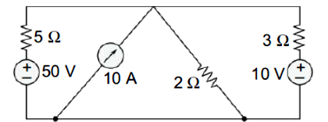 | L3 | CO1 | [4M]
 | b) | Determine the B_{f} matrix for a graph with  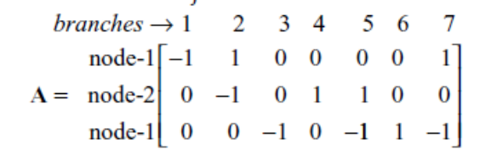  Without drawing the graph. Use {2,3,5} as twigs. | L3 | CO2 | [3M]
 | c) | Find the equivalent inductance between the terminals ab for the coupled circuit shown. M=0.5H, all the coils are coupled.  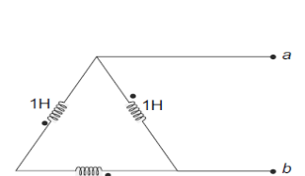 | L3 | CO3 | [3M]
18. | a) | For the circuit shown in fig, determine the total current I_{T} , phase angle Ө and voltage across each element.  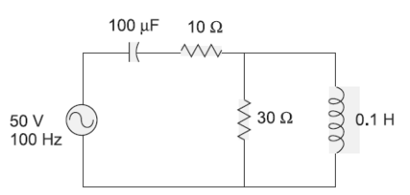 | L2 | CO4 | [4M]
 | b) | Explain series and parallel resonance. What are their similarities and dissimilarities? | L2 | CO5 | [3M]
 | c) | Show that reciprocity theorem is valid for the circuit shown in fig.  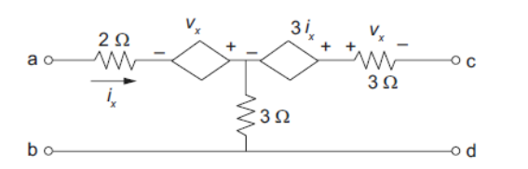 | L3 | CO6 | [3M]
-- 00 -- 00 –

